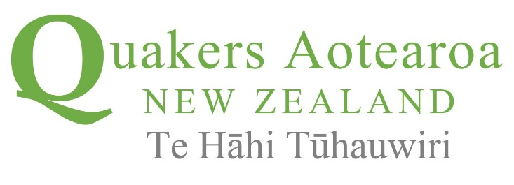

The Religious Society of Friends, commonly called Quakers or Friends, began in northern England in the 1650s as a religious movement outside the mainstream churches. It soon spread over Britain, across to America, and is now world-wide.

For more information see www.quakers.nz

At this critical time in the history of New Zealand, and the world, the Quaker Community wishes to convey to you and to the broader community, some principles and values that we feel are key to the decision making that will guide the nation to a better future.
We invite you to consider the enclosed
Call for Action

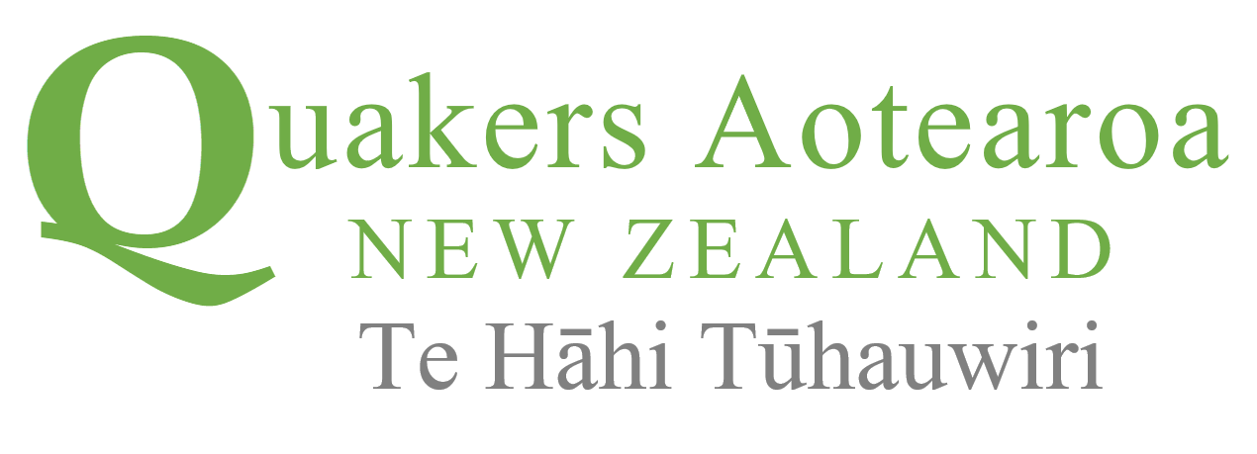

A Call for Action
after Covid-19

HOPE
We Quakers find hope in the communal response to the Covid-19 crisis across our nation. The collective action of New Zealanders has demonstrated how much we can achieve together in a short time. We see the current pandemic as a warning which creates an unprecedented opportunity for systemic change and as a call to remodel our nation guided by the principles of sustainability, non-violence, simplicity, and equity. This is a transformation that will require redistributive and regenerative economic, government and social policies that ensure all members of society benefit in an equitable manner.
VISION
Our vision is of a society that is inclusive and respectful of all people. We affirm the special constitutional position of Māori and a Treaty-based, bi-lateral system of government. We seek government which leads with integrity, shares information based on evidence, and engages with communities prior to decision-making. We oppose violence at every level and look to practices that bring peaceful dialogue and non-violent management of conflict.
SANCTITY
Quakers have a strong sense of the sanctity of creation. We are committed to the development of systems and new societal norms to rebalance climate disruption, preserve biodiversity and water quality and enable New Zealanders to live simpler lives within sustainable natural boundaries. We support the use of national resources to provide housing, low-carbon transport, and regenerative food production to benefit future generations.
CONSUMPTION
We see that society has been putting profit and consumption above other considerations despite clear evidence that earth’s natural limits have been exceeded. Consumer lifestyles have been destroying the natural ecosystems required by future generations. Decades of neoliberal economic and social policies have allowed a few people to set the agenda and benefit disproportionately. This has condemned many to low wages, poverty and insecurity whilst also degrading the environment.

OPPORTUNITY
Quakers consider that the current pandemic offers the people of Aotearoa New Zealand a chance to reassess the situation and to create a new sense of community and purpose. The Light of the Spirit has inspired Quakers through the generations into social and environmental action. We see this experience with Covid-19 as the impetus to find a way forward based firmly on the Quaker values of peace, simplicity, and equity

ACTION
Quakers call on every person in Aotearoa New Zealand to bring about whatever changes they can to enable us to live in harmony with one another and with the planet

