
Join us at
Friends Summer Gathering 2022-23
28 December – 2 January

Venue: Marsden Bay Christian Camp,
One Tree Point, Northland

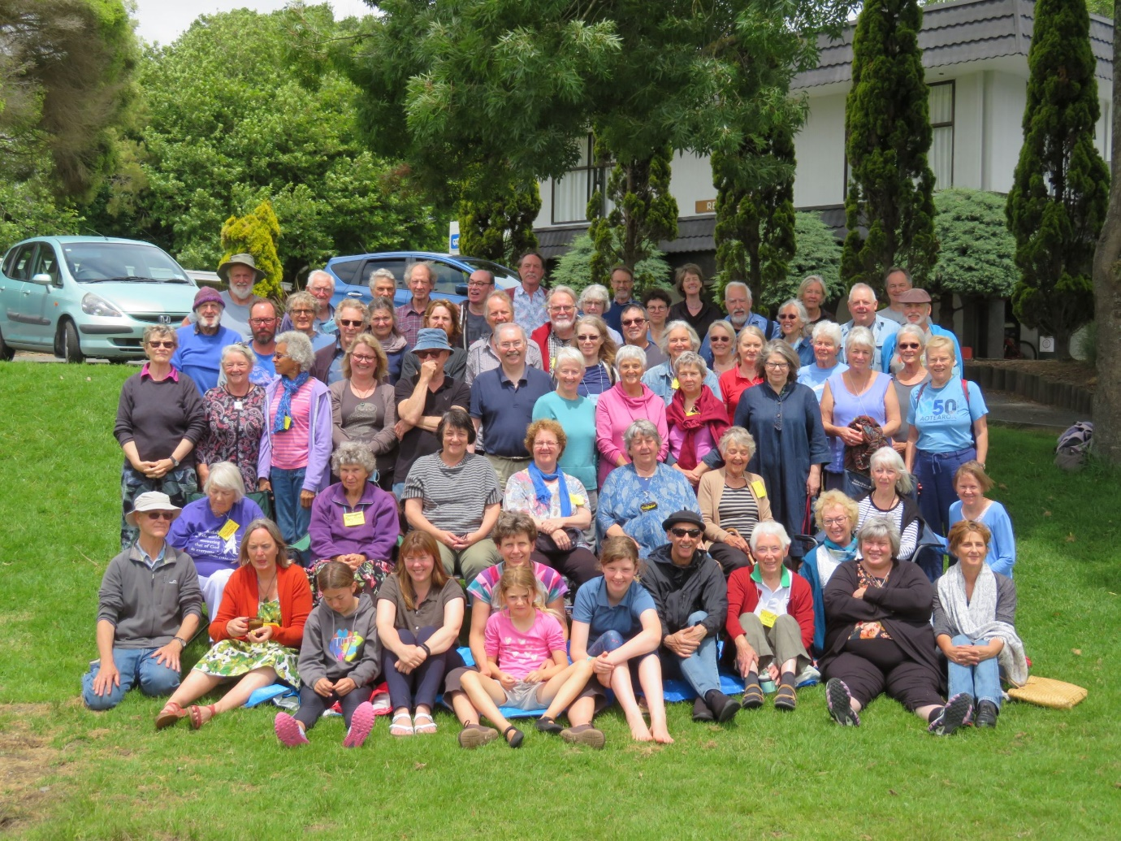
Summer Gathering participants 2020-22, Waikanae
Summer Gathering is our annual intergenerational experience of Quaker community.
Our programme will explore the proverb: Aroha mai, aroha atu.
We’re keeping costs as low as possible. Children under 18 are free; young adults (18-24 years) are half price. And there is additional financial support available.
We will follow public health advice. Be prepared for RATs and Masks!
Please come!
Early Bird Discount deadline: 15 Oct. Deadline for registration: 15 Nov. Last day for late registration: 15 Dec.
To register, follow this link: ttps://quakers.nz/sg22
For more information about the venue, visit: https://marsdenbay.co.nz/
Questions? Contact the organisers on summer.gathering@quaker.org.nz or phone 09 378 8008.

