NELSON RECOGNISED MEETING NEWSLETTER

Quakers - the Religious Society of Friends – Aotearoa New Zealand Te Hahi Tuhauwiri
October 2023

Spiritual Thought
“Contemplation is not a state of coma, or of religious reverie. If it is genuine prayer, we find our inward life quickened. We sense new directions, or our attention is refocused on neglected ones. We find ourselves being mobilised and our inward resources regrouped in response to the new assignment.”
Douglas Steere, from Dimensions of Prayer: “The Dialogue of Prayer and Action” 1963

News of and for Friends
Jan and her siblings gathered to inter their sister’s ashes in Auckland in the first weekend in October. She describes it as “wonderful, very satisfying”. She and another family member improvised a service which was followed by lunch together.
Lawrence and Marie are enjoying their newly rented home in Atawhai which affords them panoramic views of Tasman Bay. Lawrence had a birthday on 12th October and got hearing aids the same day. He’s happy with them. Marie has a sore back and is recovering. They have been planting potatoes in the community garden and in their own garden.
John M is preoccupied with ill health of family members: his sister in South Africa
has severe health problems. John may need to go there at a moment’s notice. His son in Austin, Texas is to have a serious cancer operation in 2 weeks’ time. Anthea has been having ear problems.
Elizabeth had been working hard in the lead-up to the election distributing information about how each of the parties lined up on climate issues. Her next Joy Ride (a monthly cycle tour of the city) will be on Friday 27th October, starting from Millers Acre at 5.30pm.
Shona has achieved a prize in her first foray into short story writing. She placed second in te Tau Ihu NZ Society of Authors competition. You can read her poignant story on the News page of the quakers-in-nelson website.

John D is spending time in silence and listening more as a spiritual discipline. Having become aware that he is eager to leap into conversation with his own anecdotes, he says he wants to make more space for others to talk.

Peter is busy with the Nelson Civic Choir. Having performed as part of the World Week of Prayer, they are preparing a concert, “Joy to the World” to be performed in the Cathedral on December 1st at 7pm and Dec 2nd at 2pm. Peter has been seeing his recently discovered "non-dualist" spiritual practice as complementary to Quaker Meeting for Worship practice, in the sense that he has been clear on "what we are doing" in MfW, (i.e. sitting in the presence of god), but not so clear on "how to do it". The non-dualist teaching is clarifying that for him.

Phillida is tossing up about whether to use her purchased tickets and visit the UK in late October. She had a trip recently to Wellington where she was present at a powhiri for Te Hira Pere and his wife, to welcome him into a new job and to recognise that she is impacted too by his work life. Phillida got married to her very long term partner John on September 2nd; she and her guests enjoyed a happy celebration.

Ocean is staying with her grandmother Phillida while her mother is away on a work trip. She has been enjoying play dates with her best friend. She has a new teacher and is learning te Reo.

Lizi, Amelia and Ruby (Lizi’s grandchildren) had a great time making and icing cup cakes and learning about and incorporating the concept of Ubuntu on World Quaker Day, Sunday October 1st, as part of a shared lunch for the members of the Meeting and some visitors. When supply exceeded demand they set up a stall and gave their cupcakes away to passers-by.

Linda in Motueka meeting is going to be away from the local community more in 2024 as she and her partner seek work on orchards in Central Otago and then back in Motueka. Sally has effectively been made redundant and is retraining by learning to drive a forklift. Both welcome this change as a new adventure.

DIARY OF EVENTS:

Wednesday October 18th 7pm-9pm Home Discussion Group, topic, and venue to be advised

Saturday October 21st to Monday 23rd, Whanganui Settlement, Te Tiriti Refresher and Weekend: For those with some background and also those new to Aotearoa New Zealand’s Treaty history. The theme for the weekend is “co-governance”. Contact person, Peter Watson email: earlyyearstoys@gmail.com
Friday October 27th, Millers Acre, Nelson City, 5.30pm the next Joy Ride, (cyclists reclaiming the City) For details contact Elizabeth.

Sunday 29th October about 11.30 am, after Meeting for Worship:
Arthur Wells is offering a workshop on non-violent communication. Arthur from Christchurch MM is a Quaker, a Buddhist and an excellent teacher who is highly recommended. It's short notice but will be very worthwhile.
Sunday November 5th Parihaka Day: Anzac Park Whakatu Nelson 5.30am, Dawn Blessing; following the Blessing, at the Bridge Club 21 Haven Road Nelson, Breakfast; Nelson Cathedral 12.30pm performance by Te Ora Hā. All hands on deck, contact John D to offer your kai and mahi for the breakfast.

Sunday November 5th 12.15pm Christchurch Monthly Meeting, Zoom link as per weekly Meetings for Worship.
Friday November 10th – Sunday 12th Whanganui Settlement: Rainbow Quakers Weekend: This weekend will be for Rainbow Quakers and for Friends who are asking questions about their sexual and gender identity and orientation. As we listen to each other's stories and have fun together, Rainbow Quakers can learn from one another, across differences in age and in sexual and gender identity and orientation. Co-ordinated by Elizabeth Thompson.

Sunday November 12th, Blenheim (Jos’s house) 10am,
Top of the South Meeting: 10.00 am Tea etc to refresh from the drive. 10.30 Meeting for Worship. 12.00 Shared lunch
1.00 pm Jude and Jos will share their learnings from the Faith and Play training.
Wednesday November 15th 7pm – 9pm Home Discussion Group. Topic and venue to be advised.

Sunday 19th November 11.30am after Meeting For Worship, talk by Elizabeth Duke, “How our history has shaped the uniqueness of Quaker process”.

White Ribbon Day Saturday November 25th:
Linda Glew, from Motueka Meeting writes: The annual White Ribbon Day is on 25 November. I am hoping to find out from the relevant support services in Motueka if there are any activities happening during that week or on the 25th which is a Saturday.

If there are any events in the Motueka community I want to provide a presence of Friends to support their cause of non-violence and raising the awareness for us all to play a part in reducing violence that affects women, children, men, and animals in our communities.
If there are Nelson Friends who are planning any activities for White Ribbon Day, please contact me so that we can share resources and ideas. Otherwise, as I discover what can be done here in Motueka, I will let Nelson Friends know if you wish to join us.

We warmly welcome you to our next meeting for worship in Motueka on Sunday 19 November at 10am at the Family Service Centre in Talbot Street, Motueka.

Thank you, in friendship,
Linda Glew
0274476435

Deadline for next Newsletter Our Newsletter is a way to share our lives – to help build our Quaker community. Thanks to everyone who has sent contributions. Please consider sending in your news, a book review, a quote that speaks to you…. Send newsletter items for the November letter to Jan March, janmarsh37@gmail.com The cut-off date for items for the next newsletter is Friday, November 10th, 2023.

News from Business Meeting
Closing Meetings for Worship
After experimenting with a different way of closing Meeting for Worship we have read the Quaker Handbook, talked to each other, and brought the discussion into the light of Meeting for Worship for Business.
We have agreed that a handshake, the worship sharing or reflections, and finally, the round of introductions, bring our Meeting for Worship to a close. Our Quaker Handbook advises that two approved Friends be responsible for this closing, and so we have asked the Pastoral Care Committee to bring two names forward to our next Business Meeting.
After Meeting for Worship has closed, the clerks are then responsible for correspondence, notices, any discussions arising or scheduled, and the cup of tea. In the interim, the Clerk(s) will close the Meeting for Worship.
Date of next Meeting for Worship for Business is, Sunday 3rd December 2023

Children’s Meetings
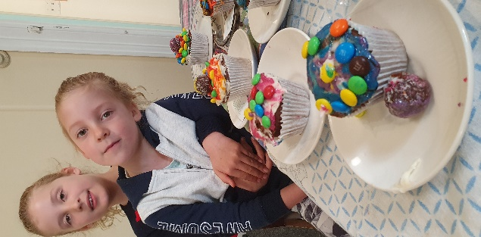
Jan and Lizi have agreed to coordinate a Children’s Committee, given we now have 5 children associated with the Meeting. We ask all Friends to assume a shared responsibility for the children and to greet their presence as an opportunity to offer ministry in care of them. If you are willing to spend 45 minutes with the children during Meeting for Worship let Lizi and Jan know, and they will look to one of us to step forward when the children arrive. You can explore the current resources in the corner of the Activities Room and in the accommodation room ahead of time, so you know what’s available.
(Amelia and Ruby with the cupcakes they made and decorated on World Quaker Day)
___________________________________________________________________
A reminder about Quakers NZ Website: https://quakers.nz/ is the database for the New Zealand Religious Society of Friends. It is a useful source of information on people and events. Please get into the habit of referring to the database, and please make sure your details are entered and up to date. This is where we go when we are looking for a Friend’s phone number, etc. This database is only as good as the data you enter so, please make use of this important communication tool. Nelson Meeting newsletters and lots of other material is posted and archived there. You can subscribe to the Aotearoa NZ Friends Newsletter there.
__________________________________________________________________

Sunday November 5th Parihaka Day – please volunteer to provide kai and mahi.

John Dainty is our Master of Rolls (Breakfast) for the feast we provide to all who have gathered at the Dawn Blessing over the city, to remember Te Whiti and
Tohu Kakahi, and with the people of Parihaka to honour their commitment to peace.
Please let John know if you are available and what food or service you can bring.
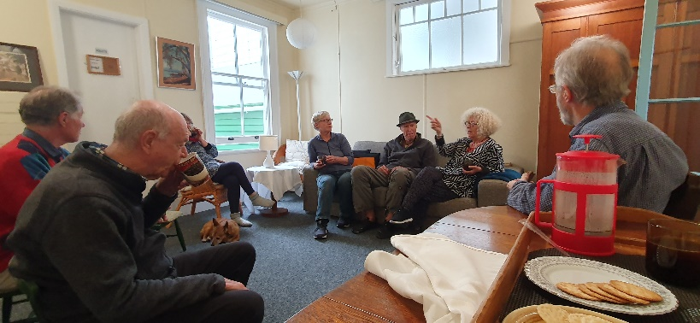
Friends relaxing during the working bee on Saturday 14th. The Meeting House got a top to bottom clean and polish.
How we spend our days
is, of course,
how we spend our lives.

How we spend our days

Annie Dillard

What we do with this hour,
and that one,
is what we are doing.
A schedule
defends from chaos
and whim.
It is a net
for catching days.
It is a scaffolding
on which a worker
can stand
and labor with both hands
at sections of time.
A schedule is a mock-up
of reason and order —
willed, faked,
and so brought into being;
it is a peace and a haven
set into the wreck of time;
it is a lifeboat
on which you find yourself,
decades later,
still living.
Each day is the same,
so you remember
the series afterward
as a blurred and powerful pattern.
Notes from Climate Correspondent’s Monthly Newsletter:
He waka eke noa - we are all in this canoe together
Note: this newsletter is not an official Quaker publication. It aims to assist Aotearoa NZ Quakers’ knowledge of action and thinking around climate change, and therefore reflects a variety of views.
Quaker Climate Emergency Correspondent 11: 6 Whiringa-ā-nuku 2023
Inspiration – Quakers join call for a Fossil Fuel Non-proliferation Treaty:
Aotearoa NZ Quakers is the first national faith community in Aotearoa NZ to join the call for an international Fossil Fuel Non-Proliferation Treaty https://fossilfueltreaty.org/faith-letter
The Religious Diversity Centre is encouraging others, and we can help put the word out: https://fossilfueltreaty.org/#endorse
Phillipa Fletcher of Wellington Meeting is the Climate Emergency Correspondent. I suggest you contact Wellington Meeting for Phillipa’s contact details, to get onto the mailing list: meeting@wellington.quakers.nz There is a heap of interesting material in her newsletter.

Summer Gathering 29 December 2023 – 6 January 2024

Friends in Dunedin Monthly Meeting warmly invite Friends and their families to Summer Gathering, taking place from Friday 29 December 2023 to Saturday 6 January 2024, at Tirohanga Camp, near Mosgiel.
The Summer Gathering Local Planning Group anticipate that registration materials will be available on the Quaker website at:
https://quakers.nz/sgcom/events/summer-gathering-2023-2024-dunedin
All you need to know is there. Register Now!
_________________________________________________________________
Online Resources: visit our own website quakers-in-nelson.org.nz, the national website quakers.nz and our Face Book page @Nelson Quakers.
If you want to find out more about what is going on right now in Gaza and the West Bank, then try Al Jazeera, Mondoweiss, Middle East Eye, 972 Magazine, Common Dreams:
https://www.google.com/search?client=firefox-b-d&q=al+jazeera+live
https://mondoweiss.net/ https://www.middleeasteye.net/
https://www.972mag.com/
https://www.972mag.com/settler-attacks-west-bank-gaza-war/ https://www.commondreams.org/news/settler-attacks-west-bank
I’m sure there are many others, but these are worth reading.
___________________________________________________________________________________
Our Programme: below is a reminder of the different activities each month.
All Sundays: Meeting for Worship, 10am, Quaker Meeting House, 30 Nile St. Nelson

2nd Sunday: Meeting for Worship, 10am, Family Service Centre, Talbot St. Motueka
3rd Wednesday: Home Discussion Group, 7pm – 8.45pm. Topic & venue tba

Children are welcome at all Meetings for Worship and activities will be provided for them.
___________________________________________________________________

