**Yearly Meeting 2017**

**Information Pack for Attendees**

Kia ora and greetings! Thanks for registering for Yearly Meeting 2017.

Yearly Meeting 2017 begins with dinner (6 pm) on Friday 12 May through to lunch on Monday 15 May 2017, finishing at 1pm. There will also be an optional preparation retreat running from 2pm Thursday 11 May through to lunchtime on Friday 12 May.

We look forward to joining with you on those days for which you have registered.

The venue is El Rancho Christian Holiday Park, 58 Weggery Drive, Waikanae Beach, Kapiti. Accommodation is in ‘houses’ of four to ten twin-share bedrooms, and each house has a lounge and self-contained bathroom and kitchen facilities. Bedding/linen and a towel will be provided for each bed and the rooms are all equipped with heaters. Yearly Meeting is fully catered (vegetarian, with a combined vegan/gluten free dietary option which you will already have registered for if required) from dinner Thursday to lunch Monday, and all meals will be served in the Elm Dining Room.

The programme for the weekend is set out in White Papers. The public Quaker Lecture will be given by Jane Kelsey on the Saturday evening 7.30pm at El Rancho.

If you have any questions please contact one of the following members of the organising committee:

* Mark Hodson, telephone 027 291 0069, email: [MarkRHodson@gmail.com](mailto:MarkRHodson@gmail.com)
* Alan Perry, telephone 04 475 7976, email: [alanperrynz@gmail.com](mailto:alanperrynz@gmail.com)
* Richard Poulter, telephone 04 528 7614, email: [richpoulter@hotmail.com](mailto:richpoulter@hotmail.com)

**Transport to and from El Rancho**

Long distance buses, frequent Wellington commuter trains, and the daily train to and from Palmerston North all pick up and drop off near the Waikanae railway station. The distance to El Rancho is approximately 5 km, and local buses depart the railway station every half-hour and drop off about 700m from El Rancho (more details follow).

Rides will be available from Waikanae railway station on Thursday 11 May at 1.45pm, and Friday 12 May at 4pm, for those who requested a ride during registration. Return rides from El Rancho to Waikanae railway station will be available on Monday 15 May at 1.15 pm, and will be organised during the course of Yearly Meeting 2017.

**Driving**

The new SH1 is up and running! North and South off-ramps lead to Te Moana Rd. Depending on which way you’re travelling, turn Right or Left in order to head West, toward Waikanae Beach. Left turn onto Waimea Rd, Left again onto Weggery Dr, veer Right to remain on Weggery Dr. The entrance to El Rancho is on the left hand side of the road, number 58, just after Gates Rd.

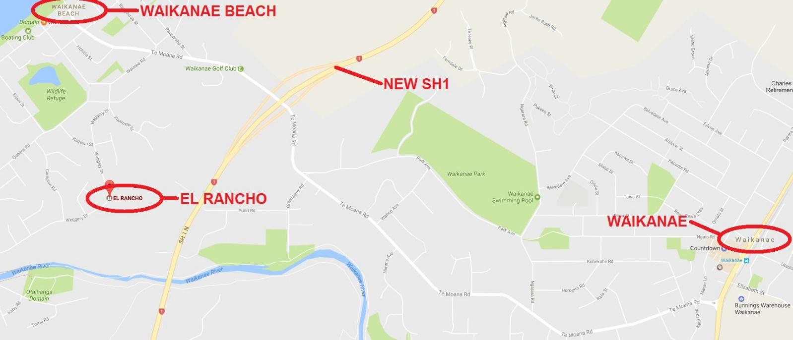

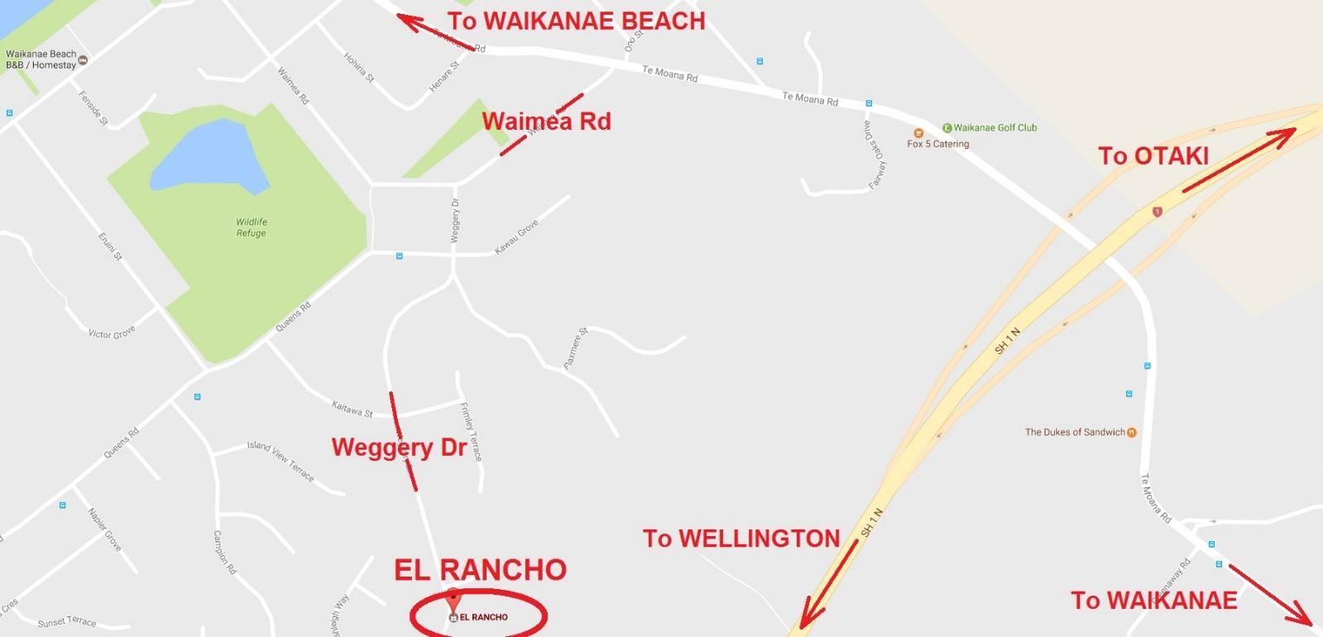

**Train or Bus to Waikanae**

The Wellington-Waikanae (Kapiti Line) train timetable can be checked online at metlink.org.nz. Trains leave Wellington station half-hourly at 14 and 44 minutes past the hour, and arrive in Waikanae one hour after departure.

For those who requested a ride during registration, we’ll meet you at the station. The collection times are Thursday 11 May at 1.45pm, and Friday 12 May at 4pm. We won’t depart without you if your train is running late.

The local bus service to Waikanae Beach is timed to coincide with the arrival of trains from Wellington. If you’re catching the local bus to El Rancho, the Main Rd bus stop is adjacent to the railway station platform. Walk south (70 metres, 1 minute – as per the following). At the other end, the nearest bus stop to El Rancho is about a 700 metre walk (Queens Road, near no. 6).

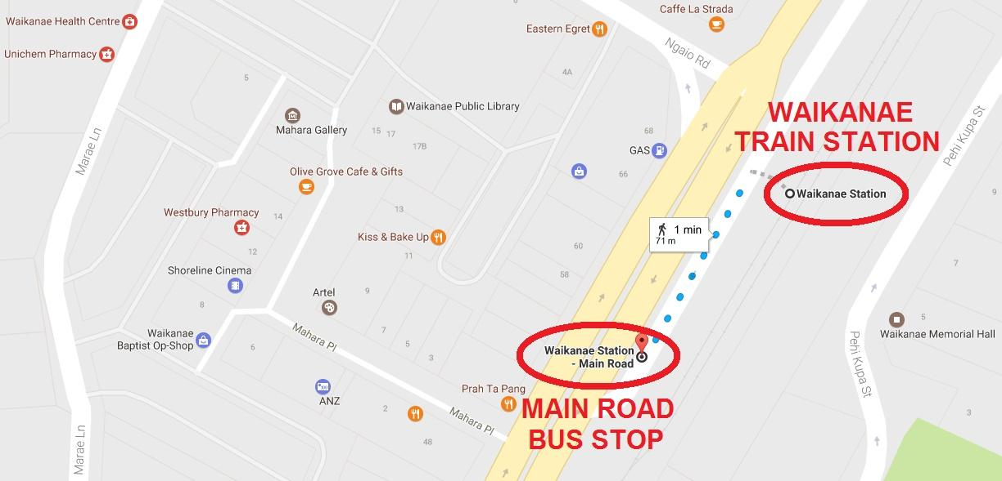

**Bus from Waikanae**

The bus will take you along the indicated route. The closest stop to El Rancho is on Queens Rd (700 metres, 8 minutes – as per the following). Note that the local bus completes a unidirectional clockwise loop around Waikanae Beach.

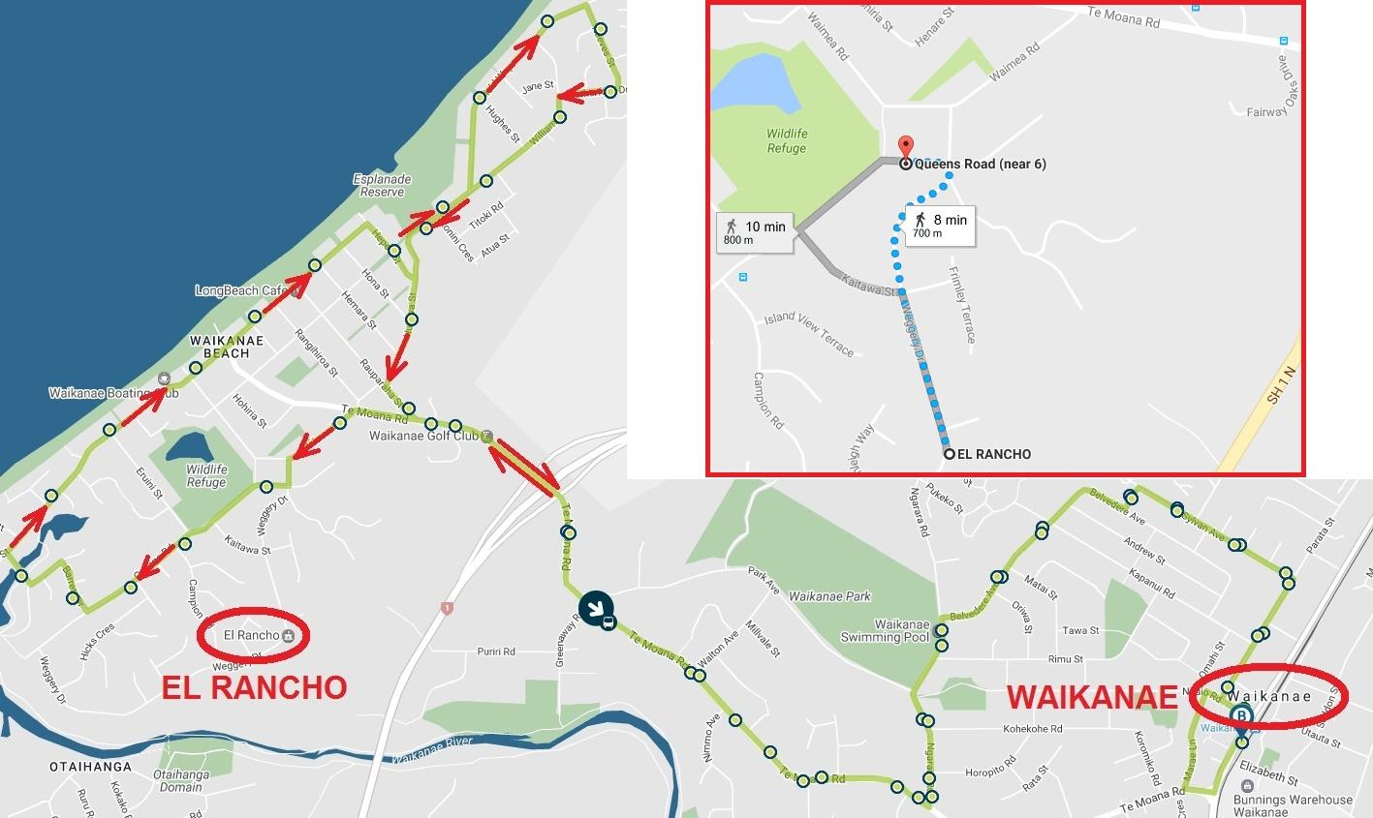

**Travel from Wellington or Kapiti Coast airports**

If you are flying in via **Wellington Airport**, the Airport Flyer bus service runs every 10 to 20 minutes from the airport terminal via Wellington downtown, with a stop at the Wellington railway station. Be sure to let the driver know you want to get off at the railway station. The cash fare is $9.00 one way (or free to Super Gold Card holders for journeys that start between 9am and 3pm weekdays, or all day weekends). The Airport Flyer is currently picking up passengers in the upper level carpark outside and across from the departures terminal (i.e., up one level from the arrivals baggage hall).

If you are flying in via **Kapiti Coast Airport**, then the airport is 2.1km from Paraparaumu railway station, and it is one stop from there to Waikanae railway station.

**The El Rancho Complex**

We will be accommodated in the Elm complex. Meetings will take place here also, and all meals will be shared in the Elm Dining room (part of the central kitchen complex). If you are driving to El Rancho, there is a carpark alongside the Elm Lodge complex.

Internet data can be purchased from the centrally located Office: $5.00/1GB, $9.00/2GB, $20.00/5GB

Tokens for the washing machines/dryers can be purchased for $4.00 each, also at the Office.

A map of El Rancho is on the following page.

