**Yearly Meeting 2017**

**Information Pack for Attendees**

Kia ora and greetings! Thanks for registering for Yearly Meeting 2017.

As you know, Yearly Meeting 2017 is being held from dinner time (6 pm) on Friday 12 May through to lunchtime on Monday 15 May 2017, finishing at 1pm. There will also be an optional preparation retreat running from 2pm Thursday 11 May through to lunchtime on Friday 12 May.

We look forward to joining with you on those days for which you have registered.

The venue is El Rancho Christian Camp, 58 Weggery Drive, Waikanae Beach, Kapiti. Accommodation is in ‘houses’ of four to ten twin-share bedrooms, and each house has a lounge and self-contained bathroom and kitchen facilities. Linen and a towel will be provided for each bed. Yearly Meeting is fully catered (vegetarian, with a combined vegan/gluten free dietary option which you will already have registered for if required) from dinner Thursday to lunch Monday, and all meals will be served in the Elm Dining Room.

The programme for the weekend will be set out in White Papers. The public Quaker Lecture will be given by Jane Kelsey on the Saturday evening 7pm at El Rancho.

Please find attached some useful information, including maps of El Rancho and the surrounding area, which we hope you will find helpful in getting to and from Yearly Meeting 2017 and enjoying the Waikanae Beach location.

If you have any questions please contact one of the organising committee on the Yearly Meeting 2017 email address:

* [nzYearlyMeeting2017@gmail.com](mailto:nzYearlyMeeting2017@gmail.com)

**Transport to and from El Rancho**

Long distance buses, frequent Wellington commuter trains, and the daily train to and from Palmerston North all pick up and drop off near the Waikanae railway station. The distance to El Rancho is approximately 5 km, and local buses depart the railway station every half-hour and drop off about 200m from El Rancho (more details follow).

Rides will be available from Waikanae railway station on Thursday 11 May and Friday 12 May, for those who requested a ride during registration. Return rides from El Rancho to Waikanae railway station will be available on Monday 15 May at 1.15 pm, and will be organised during the course of Yearly Meeting 2017.

**Driving**

The new SH1 is up and running! North and South off-ramps lead to Te Moana Rd. Depending on which way you’re travelling, turn Right or Left in order to head West, toward Waikanae Beach. Left turn onto Waimea Rd, Left again onto Weggery Dr, veer Right to remain on Weggery Dr. The entrance to El Rancho is on the left hand side of the road, number 58, just after Gates Rd.

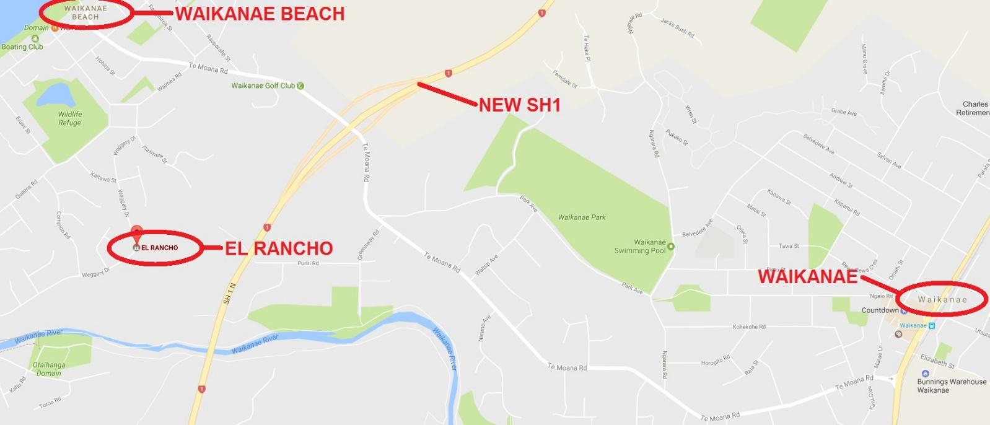

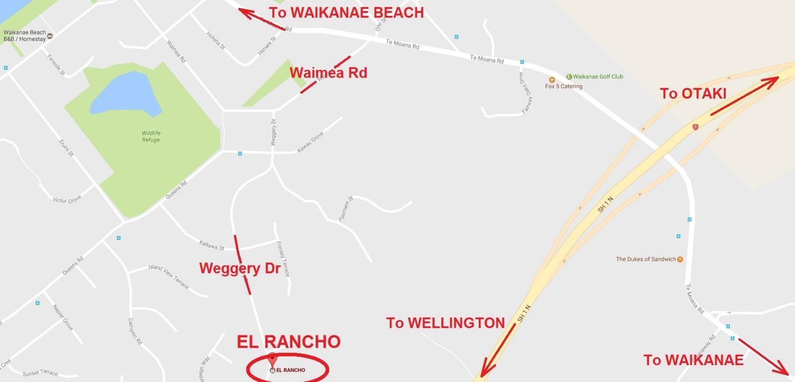

**Train or Bus to Waikanae**

The Wellington-Waikanae (Kapiti Line) train timetable is attached to this information pack, and can be checked online at metlink.org.nz closer to the time. If you’re being collected we’ll meet you at the station. If you’re catching the local bus to El Rancho walk South to the Waikanae Station/Main Rd bus stop (70 metres, 1 minute – as per the following).

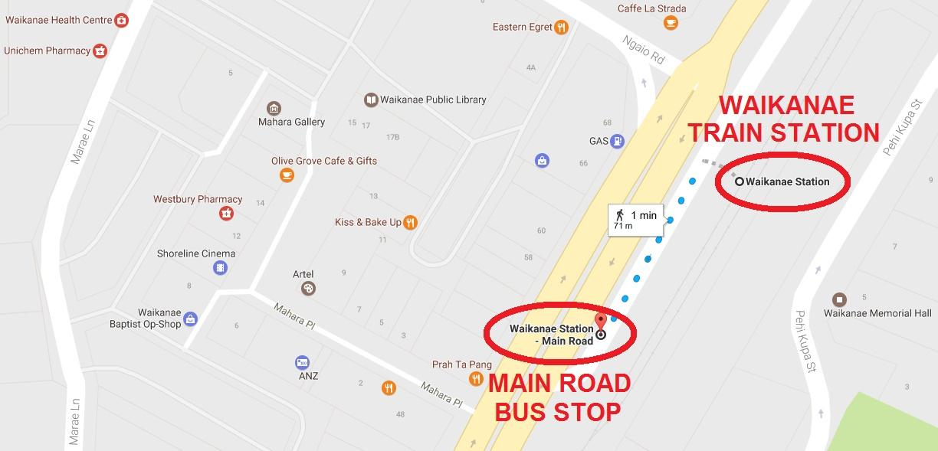

**Bus from Waikanae**

The local Waikanae (route 280) bus timetable is attached to this information pack. The bus will take you along the indicated route. The closest stop to El Rancho is on Queens Rd (700 metres, 8 minutes – as per the following). Note that the local bus completes a unidirectional clockwise loop around Waikanae Beach.

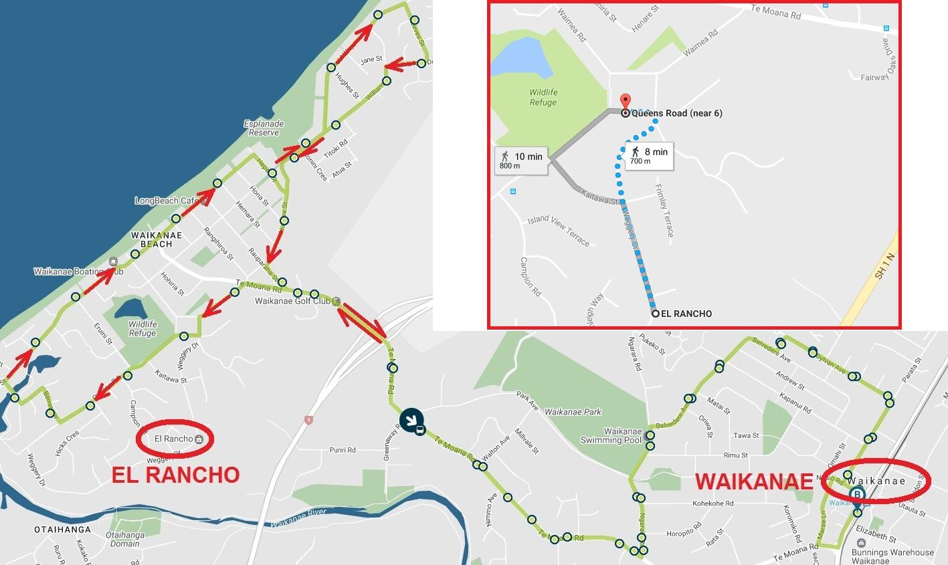

**The El Rancho Complex**

We will be accommodated in the Elm Lodge complex. Meetings will take place here also, and all meals will be shared in the Elm Dining room (part of the central kitchen complex).

Internet data can be purchased from the centrally located Office: $5.00/1GB, $9.00/2GB, $20.00/5GB

Tokens for the washing machines/dryers can be purchased for $4.00 each, also at the Office.