Cole’s Post-Palestine update – 2 Feb 2026
After six months in Palestine, my extended-tourist visa expired at the end of September, so I exited to Jordan for a week and tried to return for a renewed visa. Israeli customs denied my entry on suspicion of illegal immigration; “no one travels for that long” – as far as I know, they’re unaware that I was doing journalism, studying Arabic, and living in a refugee camp for that time, and I haven’t been blacklisted…
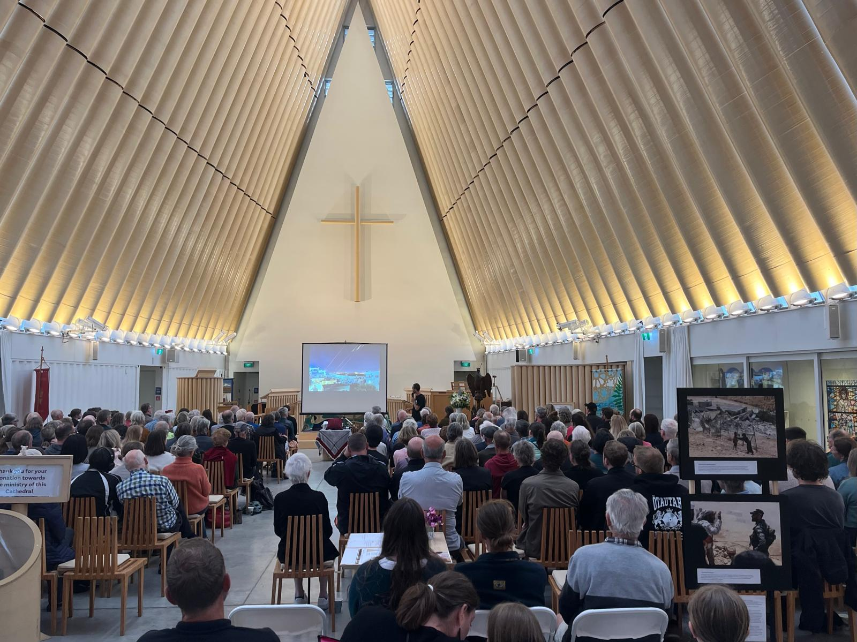
I returned to Aotearoa with sadness, but feeling the urgency to share these realities as the ‘ceasefire’/ ‘peace plan’ risked the world turning away once again (which is is exactly what has happened…)
Back in NZ I speedily reached out to contacts and pulled together a speaking tour to share my footage and stories across the motu, before hitting the road for a month and a half. Eight locations across the South Island and 19 across the north, covering over 6000km in my van and speaking to somewhere over 1500 people.
Christchurch, Alexandra, Dunedin x2, Invercargill, Christchurch again, Tākaka, Nelson, Wellington, Lower Hutt, Ōtaki, Palmerston North, Whanganui x2, New Plymouth, Hamilton, Auckland x2, Kerikeri, Auckland again, Raglan, Tauranga, Whakatāne, Gisborne, Hastings, Taupō, and finally Raetihi!
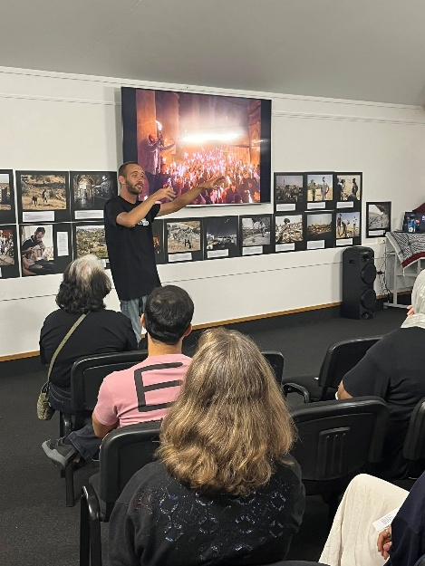
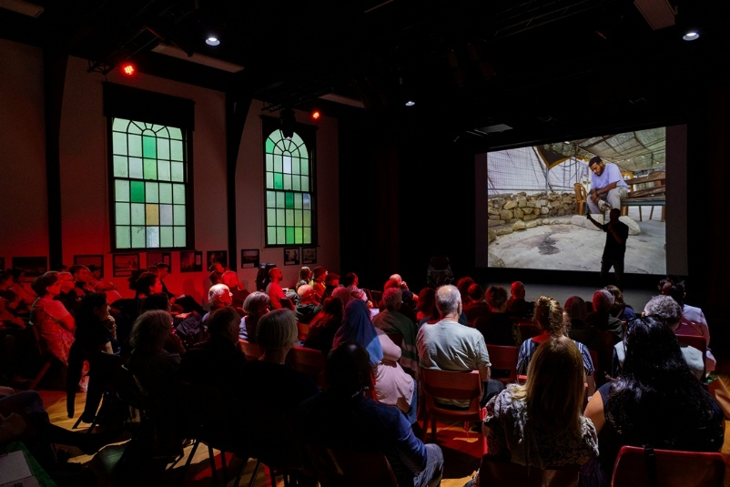
We managed to pack out Christchurch Transitional Cathedral with over 250 people. In Wellington I met with a handful of MPs from both the government and opposition parties (not very promising conversations, but hopefully fruitful in the long-term). And across that period my experiences and insights garnered wide media coverage on The Press, The Spinoff, TVNZ Breakfast, Te Ao Māori News, Otago Daily Times, RNZ, The Post, Life FM, Rhema radio, Anglican Taonga, Anglican eLife, Metro News, The News in You podcast, Raglan Community Radio, OAR 105. 4FM Dunedin, Café Pacific, and speaking at several rallies across the motu.
The tour also allowed our AC4PP movement to support local groups, deepen and establish connections, and build our mailing list to almost 800 people – hopefully laying some groundwork for future speaking tours if we can bring Palestinian Christians and others here to share their firsthand experiences and insight.
Although it was a little physically exhausting doing back-to-back talks most nights, it’s been such a privilege meeting with pockets of community doing important mahi in their local areas, particularly Palestinian whānau, and being trusted to steward these stories and hold this space for people to learn, be moved, and engage further in this Kaupapa for peace and justice.
I had some hearty conversations and deeply encouraging feedback, like; “Cole, my mum was really on the fence and quite nervous about going along last night. I just called her to see how she found it, and she was floored. She thought the whole experience was so well put together and you have changed her perspective completely.” With organisers in several other locations eager to have me speak there also.
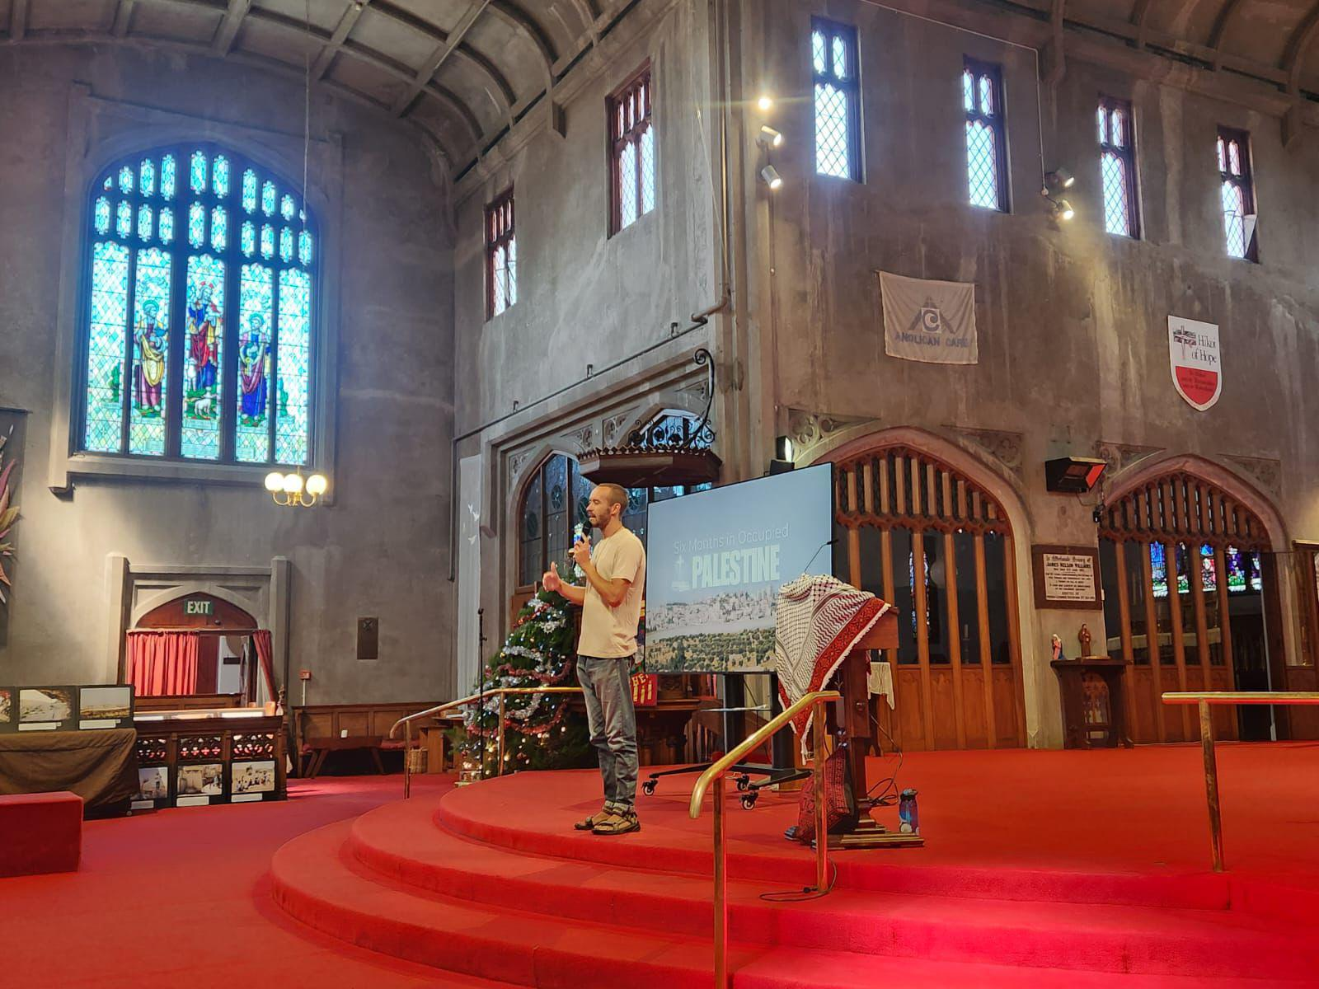
Over January I attended some Christian festivals, building trust and connections for stronger involvement in future years (hosting a stall, workshops, speaking, etc) and will be one of the keynotes at Te Huarahi Passionfest in Waikanae this Feb. For now, I’m continuing to edit the video resource Beyond Pilgrimage, aiming to launch by May, and hoping to return longer-term to Palestine this year on a study visa – if I’m able to get a visa at all! I really hope so.
I’m hugely grateful for QPSANZ support and the Loxley Award which made my time in Palestine, study, resources, and speaking tour possible. Although it can be heavy, Palestine is such a beautiful place and community to be a part of, I’ve built such wonderful and treasured friendships there, and it’s given me such deeper understanding of our own story of colonialism here in this land too. Although I’ll be gutted if I’m unable to return due to visas, it was such a privilege and joy to live there at all.
I hope to continue documenting, advocating, educating, and journeying alongside these communities and my friends in their struggle under Israeli occupation – reporting human stories and encouraging peacebuilding efforts from here in the Pacific.

