**NELSON RECOGNISED MEETING NEWSLETTER**

Quakers - the Religious Society of Friends – Aotearoa New Zealand Te Hahi Tuhauwiri

October 2022

# Spiritual Thought

“[To turn all the treasures we possess into the channel of universal love becomes the business of our lives.](https://www.azquotes.com/quote/702844)”

John Woolman (1837). “A Journal of the Life, Gospel Labours, and Christian Experiences, of that Faithful Minister of Jesus Christ, John Woolman,” p.326

# News of and for Friends

**Peter** has been working on a couple of climate projects. One is the upcoming **Earth Emotions photography exhibition**, which will be showing at the Refinery Art Space in Hardy Street from November 1st to the 19th. It will be well worth seeing, fostering emotional engagement with Earth’s predicament, and therefore commitment to climate action. The other is a behavioural change campaign called “Take the Jump.” Its based on UK research. Both are part of the Nelson Tasman Climate Forum’s activity.

**Jan**’s sister Annette died on the 7th of October at the age of seventy-five. Our condolences go to Jan.

**Lawrence and Marie** had some time out in Auckland recently ‘rabbit sitting.’

**Lawrence** has been busy with Premises jobs like overseeing the installation of a heat pump and air purifier and contesting intrusions by our neighbours with unauthorised constructions. These have damaged the storm water drains. Fortunately, Nelson City Council sees matters our way.

**Marie** is enjoying being grandparent to a 2 year old who can count up to ten. She is very much enjoying the Te Reo classes.

**Phillida** has been visiting family in Wellington. She took a weekend off to attend the Treaty Relations workshop at the Settlement.

**John M** has started writing the music for a theatre production on climate change, aimed at children. Lindsay Wood has written the script. This isn’t John’s first foray into musical theatre, having previously written the music for a play on apartheid.

**Gwen** is busy putting in vegetable seedlings. She does yoga every morning and is keeping busy with Friends of the Haven. A daughter visits her every month, and she has a part-time house mate.

**John D** is back from his walking holiday in Ireland. He has swung into action organising the breakfast to follow the Dawn Peace Blessing on Parihaka Day. Because it is a Saturday, he expects a bigger turnout this year.

**Christine** returned from her holiday in London visiting her son, his partner, and grandson. She is now reading Winnie the Pooh to them all every weekend by video.

**Lizzie** was busy organising in the weeks leading up to the blessing of the Nelson Quaker Embroideries on October 16th. Because the central roundel has a bi-cultural theme we were honoured that Maori Anglican Arch Deacon Harvey Ruru blessed the beautiful works created by Lizzie and Patricia and worked on by many in the Meeting.

**John M and Christine** have been meeting with Worship groups throughout the South Island, meeting with Friends in Golden Bay mid-September, to discuss Outreach.

DIARY OF EVENTS:

Thursday October 20 to Sunday October 30: Nelson Arts Festival: <https://www.nelsonartsfestival.nz/>

Wednesday October 27th 7pm Quaker Meeting House, 30 Nile Street, Nelson: Discussion on participatory democracy and Te Tiriti based People’s Assemblies. Presenters: Ami Kennedy and Te Wehi, who have offered to explain the ideas behind Peoples Assemblies and how we could use them here in Nelson to examine local issues and find consensus.

Friday October 28th 10am Chandrakirti Meditation Centre Sunrise Valley Road, Upper Moutere, Interfaith Gathering. Everyone welcome.

Saturday November 5th 5.30am Anzac Park, Nelson, Parihaka Day Commemoration and Celebration, Dawn Peace Blessing over the City, followed by breakfast at the Bridge Club adjacent. Bring family and friends.

Wednesday November 9th 7.00pm – 8.15pm, by Zoom, and on 5 successive Wednesdays: Discussion Series: What should a Quaker Statement on Transgender say?

# News from Business Meeting

Premises:

**Heat Pump**: At our Business Meeting in August we decided to install a heat pump along with an air purifier, to replace fan heaters that were unsafe. It is now in and warming the Meeting Room and Activities Room beautifully. It is programmed to come on automatically, but efficient at bringing the temperature up quite quickly. It has reduced the Relative Humidity levels in the Meeting House from around 80% to 40 – 60%.

**Electric Switchboard:** this was inspected mid-year and a recommendation was made to replace the old switchboard, but not made a requirement. We may consider replacing it in the summer. If we do, we may need arc detectors to protect the remaining old wiring, at a potential cost of $10,000.

**Dampness and Basement Flooding**: extensive building works by our neighbours has affected the Meeting House – our stormwater downpipe was disconnected, and the water flowed into our basement. Repairs then rerouted it onto our sunroom roof, so water cascaded onto the footpath. The neighbour’s storm water continues to be directed into a defunct sump and thence into our basement. Lawrence is holding discussions, and we now have the support of the Nelson City Council.

**Fence and side yard**: Our neighbours have built a fence directly alongside the existing one, overtopping ours. They have agreed to clad the exposed part on our side of the fence but haven’t so far. A new deck has been built over the shared side yard. Discussions continue.

Meetings for Worship With the ending of Covid vaccine passports and mask requirements the original reason for having two meetings no longer applies. However, Friends have come to enjoy having options for attending Meeting for Worship. We decided to continue with an early Meeting at 8.45am, lasting 45 minutes, and an hour long mid-morning Meeting at 10am. Everyone is welcome at both Meetings.

**Use of Zoom**: we agreed to continue to offer Zoom attendance for Business Meetings as well as meeting in person.   
  
Subsidy for attendance at Settlement Seminars  
  
We encourage Friends to attend seminars at the Whanganui Settlement. We agreed to offer a subsidy of $200 for travel for up to five Friends to attend seminars in the next year. We ask any Friend who wants a subsidy to approach the Pastoral Care Committee. We would like all Friends who go to a Whanganui Settlement seminar to briefly report back after Meeting for Worship.  
  
Next MfW for Business: Sunday 4th December 2022

|  |  |  |
| --- | --- | --- |
|  |  | |
|  |  | |
| Hymn to time |  | |
|  |  | |
| Ursula K. le Guin |  |

|  |  |  |
| --- | --- | --- |
|  |  |  |

Time says “Let there be”  
every moment and instantly  
there is space and the radiance  
of each bright galaxy.

And eyes beholding radiance.  
And the gnats’ flickering dance.  
And the seas’ expanse.  
And death, and chance.

Time makes room  
for going and coming home  
and in time’s womb  
begins all ending.

Time is being and being  
time, it is all one thing,  
the shining, the seeing,  
the dark abounding.

Invitation to the Dawn Peace Blessing over the City, Parihaka Day, Saturday November 5th, 2022 – ANZAC Park 5.30 am.

Ngā mihi maioha ki a koe.

Whakatū Parihaka Peace Network Connection and the Nelson Quakers invite you to join with us on Saturday November 5th to commemorate Parihaka Day and ngā tāngata o Parihaka. There will be an opportunity to offer karakia, prayers, thoughts, kōrero, waiata or hymns for the blessing of peace in Whakatū, if you so wish at the Dawn Blessing.

We are suggesting that speakers may like to focus on one or two of the Parihaka Principles and how we may apply them here, to maintain our vibrant and peaceful community. The whenua/kainga wae wae we love.

The connection is strong for us in Whakatū as Te Whiti-o-Rongomai and Tohu Kākahi spent eight months in Nelson under house arrest, and 200 volunteer riflemen from the Nelson community were part of the Government force against Parihaka on 5th November 1881. We will remember those who have walked before us, as we maintain a commitment to peace.

Tohu Kākahi, Te Whiti-o-Rongomai, and the generations of people of Parihaka who have faithfully brought their Legacy of Peace into our time will be honoured. They have paid an enormous cost to do this.

Please join with us and contribute to this Legacy of Peace.

Peace is the greatest treasure we can offer to our children.

**November 5th, 2022**

**Dawn Peace Blessing over the City – ANZAC Park 5.30 am**

Nāku noa,

Nā Veronica Christie on behalf of the Whakatū Parihaka Peace Network Connection

contact details – [whakatu.parihaka@gmail.com](mailto:whakatu.parihaka@gmail.com)

**Kia tau te rangimārie ki runga i a koe** let peace settle upon you.

**___________________________________________________________**  
Deadline for next Newsletter Our Newsletter is a way to share our lives – to help build our Quaker community. Thanks to everyone who has sent contributions. Please consider sending in your news, a book review, a quote that speaks to you…. Send newsletter items to Elizabeth Dooley elizdooley@hotmail.com The cut-off date for items for the next newsletter is Friday, November 11th, 2022.

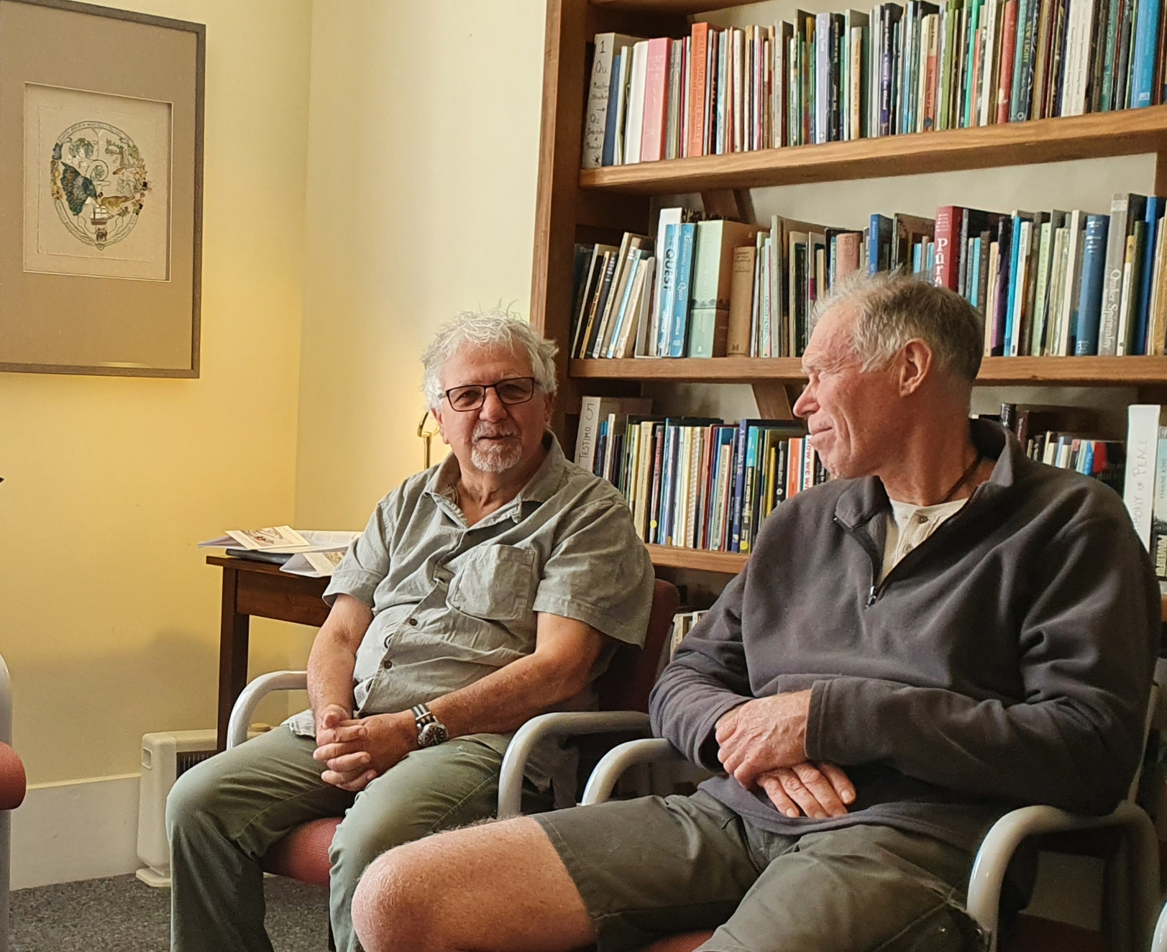 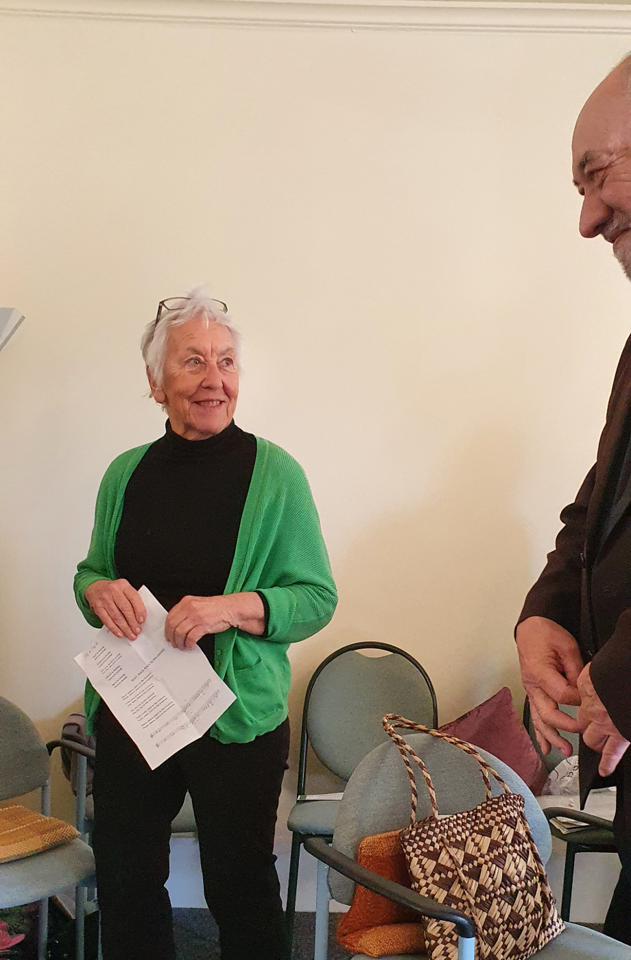

Blessing of the Nelson Quaker Embroideries, October 16th, 2022

from top left: Harvey and Lizzie chatting after the Blessing, John and a guest relaxing alongside the 3rd roundel depicting the meeting of tangata whenua and the first Quaker arrivals in Nelson, Shona and Harvey enjoying a moment, and below Lawrence and Harvey at the end of the Blessing. 24 Friends and family attended the event.

­­­­­­­­­­­­­­­­­­­­­­­_____________________________________________________________

Can a pacifist engage in self-defence?

This was the subject of a Home Discussion in October, introduced by John M and Clive. Clive spoke about his view that each person must make their own choice regarding the Peace Testimony according to his or her conscience. It is an individual responsibility. Quakers do not demand anything except that each be guided by the Light. For some Friends this has meant taking up arms, others could never do so.

John shared his conflict – he supports the Testimony yet feels a surge of hope whenever the news reports a ‘win’ for Ukraine. He then shared a video Peter had provided entitled The Pathway to a Negotiated Peace in the Ukraine with Jeffrey Sachs, <https://www.youtube.com/watch?v=IrFPocqaE78> , which highlights the role of the USA and NATO in the prosecution of the war in the Ukraine.

Discussion began to focus on historical rights and wrongs, with Russia being promised NATO would not move eastwards after the dissolution of the USSR, a promise not kept. Yet countries on Russia’s borders newly free from Soviet domination feared for their national security and were not inclined to be human shields for Russia or the West. This circle could not be squared.

Our discussion turned to the origins of the Peace Testimony, which was in itself a sort of self-defence action, as Quakers sued for peace with King Charles II, assuring him they wished to live quiet lives and asking for religious tolerance. Quakers have sought to be peace makers ever since, not taking sides in conflicts which in any case cannot be settled by violence but seeking to reconcile warring parties to the opportunities for peace. The question arose: what are Quaker peacemakers doing internationally to try to bring about peace in the Ukraine?

We decided we would find out. John M is to enquire about QUNO activity in Geneva, and Clive will see if Kevin Clements has any news of peace making. We will then decide what we can do to support those peace efforts.  
__________________________________________________________________

A reminder about Quakers NZ Website: <https://quakers.nz/>is the database for the New Zealand Religious Society of Friends. It is a useful source of information on people and events. Please get into the habit of referring to the database, and please make sure your details are entered and up to date. This is where we go when we are looking for a Friend’s phone number, etc. This database is only as good as the data you enter so, please make use of this important communication tool. Nelson Meeting newsletters and lots of other material is posted and archived there. **You can subscribe to the Aotearoa NZ Friends Newsletter there.**

______________________________________________________________

Online Resources:visit our own website quakers-in-nelson.org.nz, the national website quakers.nz and our Face Book page @Nelson Quakers.

Here are two articles that Friends were invited to read for the home discussion on 26th October:

|  |  |
| --- | --- |
|  | [A Democratic Tool for the Climate Emergency | Newsroom](https://www.newsroom.co.nz/a-democratic-tool-for-the-climate-emergency)  Climate Emergency. A democratic tool for the climate emergency Pat Baskett makes a case for citizens' assemblies as a way to address the gap between government policy and a climate anxiety verging on terror |

<https://www.newsroom.co.nz/a-democratic-tool-for-the-climate-emergency>

Dear Friends,

Firstly, Thank You, Ami, and Te Wehi for bringing us the seeds of a way to gather together and find a way to play a role in shaping the future of Aotearoa. As you said, Te Wehi, we need to grow the idea of participative democracy and re-engage with all the members of our society to work towards "fair shares". I'm particularly interested in finding a small, local issue to 'experiment with'...

When I arrived home and checked the Guardian, I found an op ed by George Monbiot which is particularly apt, after much despair at the current state of the UK, particularly at the attempt to enact a law requiring protesters to wear tracking devices, he actually talks about participatory democracy:

<https://www.theguardian.com/commentisfree/2022/oct/26/rishi-sunak-britain-general-election-protest>

|  |  |
| --- | --- |
|  | [Sunak’s Britain is already broken. We need more than a general election to fix it | George Monbiot | The Guardian](https://www.theguardian.com/commentisfree/2022/oct/26/rishi-sunak-britain-general-election-protest)  www.theguardian.com |

­­­­­­­­­­­­ ____________________________________________________________________________

Our Programme: below is a reminder of the different activities each month.

Sundays: Meeting for Worship, 8.45–9.30am, 30 Nile St Nelson

Meeting for Worship, 10 – 11am, 30 Nile St. Nelson

2nd Sunday: Meeting for Worship, 10am, Family Service Centre, Talbot St. Motueka

3rd Wednesday: Home Discussion Group, 7pm – 8.45pm.

Children are welcome at all Meetings for Worship and activities will be provided for them.

__________________________________________________________________